**Idea 1: Interactions among herbivores in climate change context**

Herbivory can be an important mechanism which affects vegetation structure and successional dynamics. Browsing and grazing animals select individuals within their height range and of preferred (more palatable) species. By their effects on vegetation, herbivores can hasten succession to a state which supports less palatable browse. In this case, disturbance is an important mechanism to open growing space in a stand and allow regeneration of palatable species.

In past work, wind disturbance was found to be an important mechanism for sustaining moose populations by allowing regeneration of palatable edge-specialist species such as aspen and balsam fir in an otherwise unpalatable canopy of boreal conifers (Jager et al. 2017). Other disturbance mechanisms may be important in this ecosystem, which may influence predictions for future moose populations and inferences regarding management. Particularly in a warming environment, herbivorous insects are likely to be a large source of disturbance. Outbreaks of spruce budworm or bark beetles in genera *Ips* and *Dendroctonus* can have large effects on stand structure by killing trees, especially large and densely growing trees, creating decades-long landscape legacies of altered stand structure (Franklin et al. 2015).

The effects of bark beetles may counteract some of the predicted influences of climate change on northern forests and accentuate others, but interactions with moose make predictions more difficult. While some of these effects of insect outbreaks may increase forage by opening growing space for hardwood regeneration, the combined effects of moose and spruce budworm herbivory may reduce balsam fir cover and regeneration even further (Leroux et al. 2021). Moose can accentuate the effects of spruce budworm on forest structure by utilizing the edge habitat created by tree mortality (Franklin and Harper 2016).

Northern forests are thus subjected to several kinds of herbivory with different selectivity, geographic patterns, and species preferences. Understanding how climate change may affect forest structure requires incorporating the influences of these herbivory patterns, which may sharpen or counteract effects of climate change per se.

**Question**: Do two important herbivores have compounding effects on stand dynamics? How will climate change affect those interactions?

**Methods**:

Simulations with crossed levels of beetle and moose herbivory (wolf predation)

Where to spend our time: implementing different levels of beetle herbivory and testing sensitivity to beetles.

**Idea 2: The role of beavers and wet meadow succession in landscape dynamics of Isle Royale**

Beavers may also interact with moose foraging dynamics. As central-place foragers, beavers have a more limited and predictable geographic scope compared to beetles. They primarily take small stems of willow, alder, birch, or other hardwoods, but they also fell larger trees either for food or habitat construction. Thus beavers may compete with moose for preferred species, but they may also open growing space for regeneration by palatable species. However, conifers make a comparatively minor component of trees cut by beavers (Haarberg and Rosell 2006), so beavers are unlikely to counteract the general trend to canopy dominance by conifers (De Jager et al. 2020).

**Questions:** How does ecosystem modification by beavers affect landscape change?

**Methods:**

Develop a model of beaver effects – selection for species and size classes, spatial location, influence on hydrology (?)

Implement beaver model into LANDIS

Update initial communities in LANDIS to include wetlands

Where to spend time: implementing beavers as a BDA or Harvest; improving models of wet meadows (e.g., create ecoregion to suppress recruitment of most trees).

Initial communities file has some gaps that might be filled in, for example this ridge which has some trees and patches of forest:

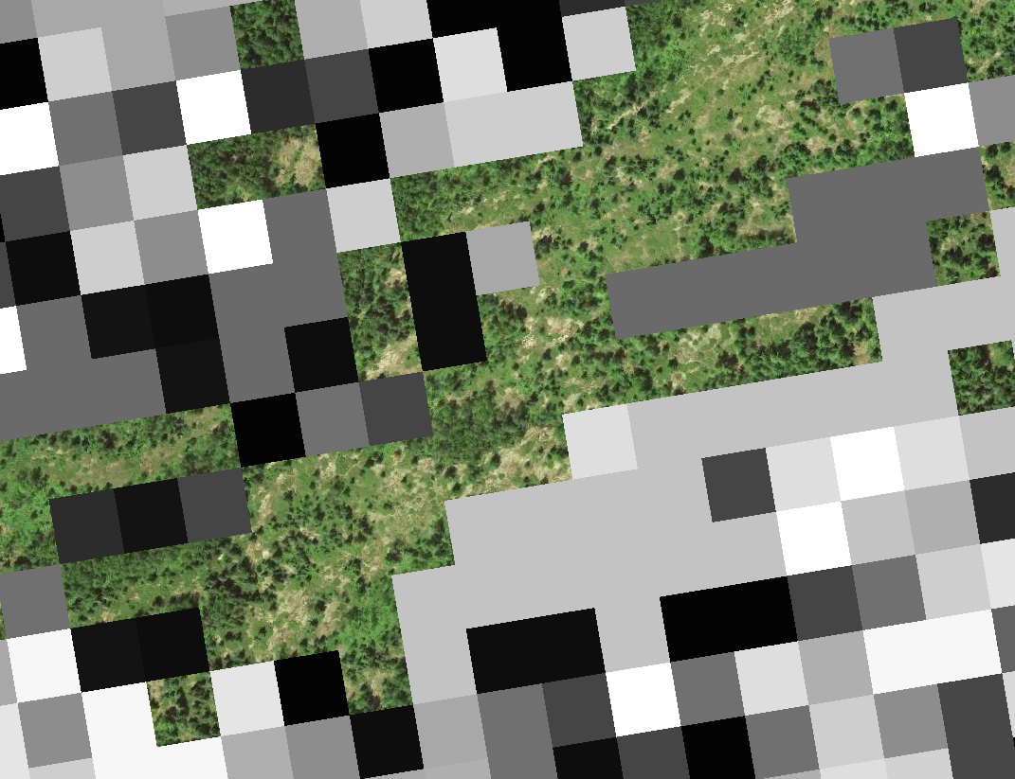

**Idea 3: Climate change affects on carbon and nitrogen dynamics of Isle Royale**

Forest structure is predicted to change in response to climate change, altered disturbance regimes, etc. Boreal forests sequester a lot of carbon in the soil. Changes in forest structure will affect aboveground biomass, but the long-term carbon dynamics of such changes in forest structure are unknown. We will use Isle Royale as a case study in northern forest dynamics.

**Question:** How will carbon and nitrogen pools change in response to climate change? Will beetles and moose and beaver affect carbon dynamics? What influence might wolf management have for ecosystem dynamics?

**Methods:**

Spend time: parameterize NECN

**Idea 4: Change detection in wetlands using LandTrendr**

Associated with Task 1 from original study plan. Just a quick sketch, since I was curious what landscape changes were common at Isle Royale. GEE implementation of LandTrendr with easy interface here: https://emapr.github.io/LT-GEE/ui-applications.html

**Question:** How stable are wetlands? What is the periodicity of beaver impoundment? What consequences for landscape patterns?

**Method:** Quantify increases and decreases in vegetation/water over time. Identify characteristic pattern of infill or new damming and map these processes over time using LandTrendr. Describe spatial pattern of infill/damming. Compare with other disturbance mechanisms (e.g. wind or beetle outbreaks).

**Example: infill of shallow lakes**

Air photo 1998 – lots of open water and marsh, relatively new beaver dams on both lakes

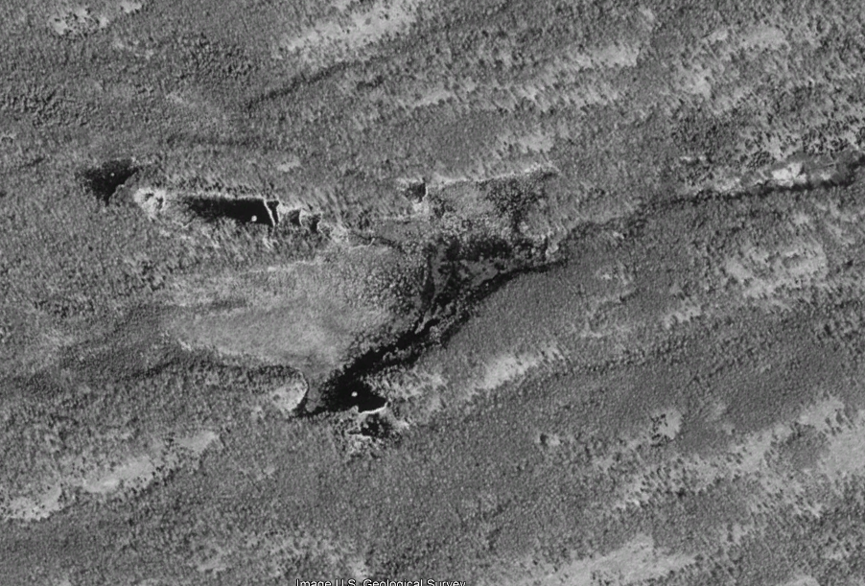

2017 – open water has filled in, expansion of beaver dams:

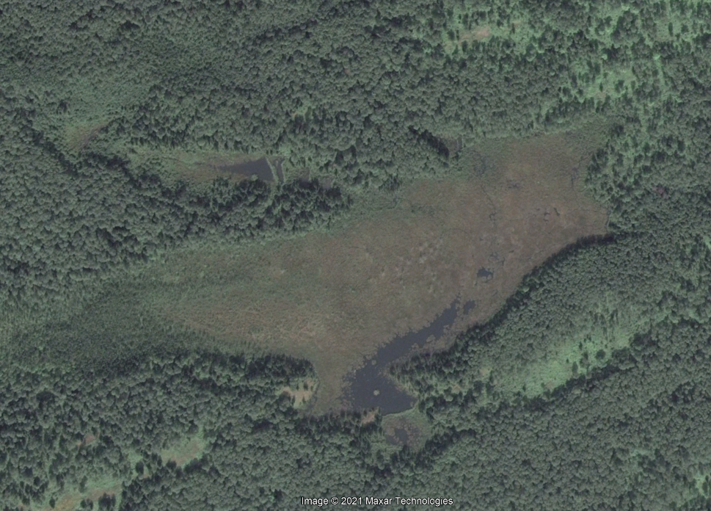

LandTrendr change detection, loss of TCW greatest at edges of open water:

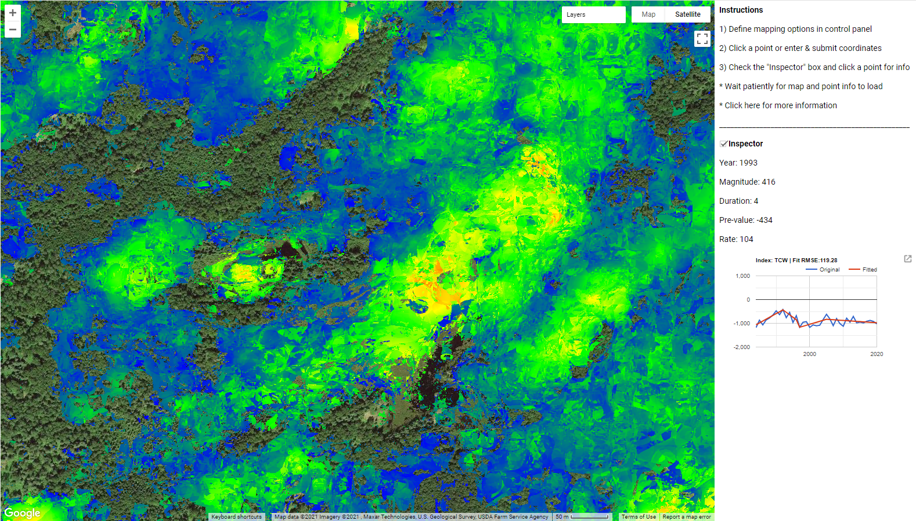

Really striking beaver-caused spatial patterns: 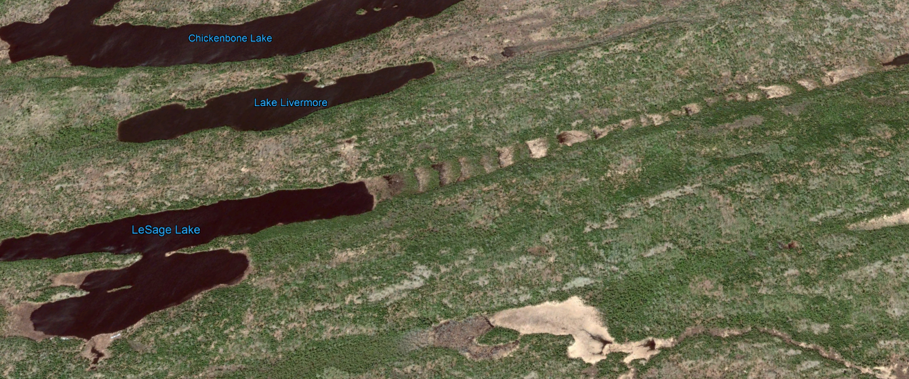

**Bibliography**

**Beavers**

(Vorel et al. 2015)Beaver biomass consumption and diameters of trees selected

(Raffel et al. 2009) Beaver selection changes with distance from center – larger trees and more selective at further distances

(Gallant et al. 2004) Beaver selectivity depends on distance but also habitat quality – they’re more selective in better habitats. Good information on electivity for different species – they really don’t like conifers.

(Donkor and Fryxell n.d.) Beavers promote recruitment of non-preferred species and increase conifer dominance. They seem to suppress some preferred species, but Salix and Alnus are promoted despite being heavily foraged. Some discussion of edaphic effects

(Peinetti et al. 2009)Simulated effects of beaver foraging on willow. Interesting ecosystem effects – beavers change size distribution of willows and can increase ANPP

**References**

De Jager, N. R., J. J. Rohweder, and M. J. Duveneck. 2020. Climate Change Is Likely to Alter Future Wolf – Moose – Forest Interactions at Isle Royale National Park, United States. Frontiers in Ecology and Evolution 8:290.

Donkor, N. T., and J. M. Fryxell. (n.d.). Lowland boreal forests characterization in Algonquin Provincial Park relative to beaver (Castor canadensis) foraging and edaphic factors:12.

Franklin, C., K. Harper, and L. Murphy. 2015. Structural dynamics at boreal forest edges created by a spruce budworm outbreak. Silva Fennica 49.

Franklin, C. M. A., and K. A. Harper. 2016. Moose browsing, understorey structure and plant species composition across spruce budworm-induced forest edges. Journal of Vegetation Science 27:524–534.

Gallant, D., C. H. Bérubé, E. Tremblay, and L. Vasseur. 2004. An extensive study of the foraging ecology of beavers ( *Castor canadensis* ) in relation to habitat quality. Canadian Journal of Zoology 82:922–933.

Haarberg, O., and F. Rosell. 2006. Selective foraging on woody plant species by the Eurasian beaver (Castor fiber) in Telemark, Norway. Journal of Zoology 270:201–208.

Jager, N. R. D., J. J. Rohweder, B. R. Miranda, B. R. Sturtevant, T. J. Fox, and M. C. Romanski. 2017. Modelling moose–forest interactions under different predation scenarios at Isle Royale National Park, USA. Ecological Applications 27:1317–1337.

Leroux, S. J., L. Charron, L. Hermanutz, and J. Feltham. 2021. Cumulative effects of spruce budworm and moose herbivory on boreal forest ecosystems. Functional Ecology 35:1448–1459.

Peinetti, H. R., B. W. Baker, and M. B. Coughenour. 2009. Simulation modeling to understand how selective foraging by beaver can drive the structure and function of a willow community. Ecological Modelling 220:998–1012.

Raffel, T. R., N. Smith, C. Cortright, and A. J. Gatz. 2009. Central Place Foraging by Beavers (Castor canadensis) in a Complex Lake Habitat. The American Midland Naturalist 162:62–73.

Vorel, A., L. Válková, L. Hamšíková, J. Maloň, and J. Korbelová. 2015. Beaver foraging behaviour: Seasonal foraging specialization by a choosy generalist herbivore. Behavioral Ecology and Sociobiology 69:1221–1235.